**Cairo University**

**Faculty of Computers and Artificial Intelligence**

**IS211: Introduction to Database Systems**

**Super Market (Phase 2)**

**TA: Eng. Alia Magdy**

**Team Members:**

* Mariam Badr Yehia Abd El-Naby (S20) 20230391
* John Ayman Demian (S20) 20230109
* George Malak Magdy Nashed (S20) 20231042
* Marawan Mohammed Badr (S20) 20231157
* Mohammed Atef Abd El-Kader (S20) 20231143

**Supervised:**

**Dr. Ali Zidane El Qutaany**

1. 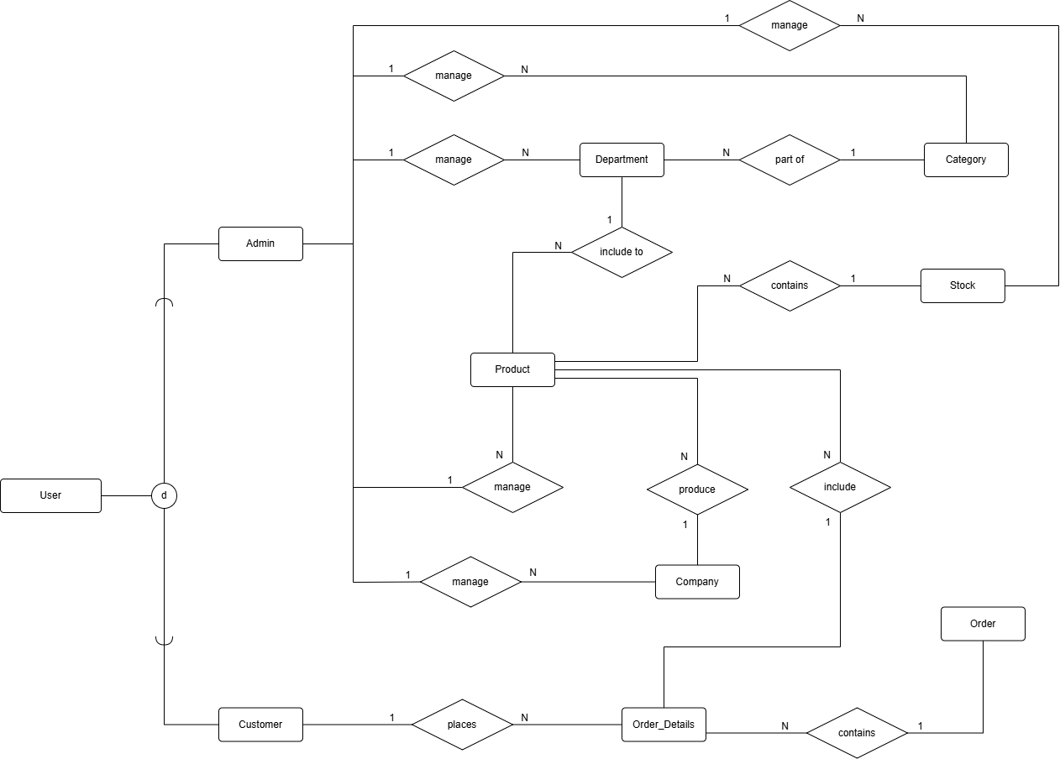**Conceptual ERD:**
2. **A black background with white squares

   AI-generated content may be incorrect.Logical ERD:**
3. 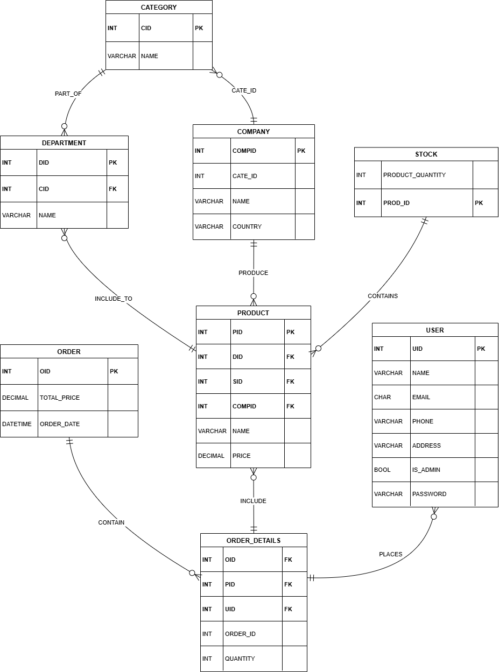**Physical ERD:**
4. **Requirements**

|  |  |  |
| --- | --- | --- |
|  | **Requirement** | **Description** |
| **RQ001** | Admin Functions | Enable administrator login functionality. |
| **RQ002** | Allow administrators to register an account. |
| **RQ003** | Allow administrators to (add, modify, delete) company records. |
| **RQ004** | Allow administrators to (add, modify, delete) product categories. |
| **RQ005** | Allow administrators to (add, modify, delete) departments. |
| **RQ006** | Allow administrators to (add, modify, delete) stock quantity records. |
| **RQ007** | Allow administrators to (add, modify, delete) products. |
| **RQ008** | Customer Functions | Enable customer login functionality. |
| **RQ009** | Allow customers to register an account. |
| **RQ010** | Allow customers to (place, modify, cancel or delete) orders. |
| **RQ011** | Most Purchased Product | Retrieve the product with the highest customer count. |
| **RQ012** | Unsold Products by Month | Identify products with no sales in a specified month. |
| **RQ013** | Inactive Customers | Identify customers inactive for the past year. |
| **RQ014** | Top Purchasing Customer | Identify the customer with the highest monthly purchase. |
| **RQ015** | Sales Comparison | Compare sales between food and electronic products. |
| **RQ016** | Product Purchase Summary | Retrieve product details with customer purchase counts. |